A
Project Report On
Airlines ticket Booking System
In Partial Fulfilment of
Bachelor of Computer Applications (B.C.A.)
Gujarat University (2025-26)



Developed By
Parmar Smita(5102)
Solanki Kinjal(5053)
Zanzarukiya Vidhi(5110)
(Sem-V Bachelor of Computer Applications)

Navgujarat College of Computer Applications
Ashram Road, Ahmedabad



Internal Guide
Pro.Ankita Patel

Acknowledgement
The acknowledgement sample for the university project is mostly attached after the dedication page thanking all the faculty members of the department, HOD, the dean and the project guide.

We are extended our sincere thanks to our collage – Navgujarat collage of computer applications , our respected principle Mr. Paresh Patel and our respected faculties for giving us a golden opportunities to work on the project of “Airlines Ticket Booking System” website and providing us their precious time , deep and valuable knowledge to make a project success.

We extend our warm thanks to our project guide prof. Ankita Patel for her guidance and constant encouragement throughout the semester for providing their valuable time , advise for various problems whenever we needed for deciding the objectives for our reports.

We are thankful to our parents, all staff members, our friends , seniors who helped directly or indirectly in our project..
Parmar Smita
Solanki Kinjal
Zanzarukiya Vidhi

Introduction

The Airline Ticket Booking System is a software application designed to simplify and automate the process of booking flight tickets. In the traditional system, customers often have to visit travel agencies or airline offices to check flight availability, compare fares, or reserve seats. This method is time-consuming, prone to errors, and lacks real-time updates. To overcome these challenges, an efficient computerized system is required.

This project aims to develop a reliable, user-friendly, and secure platform that allows passengers to search for available flights, check schedules, compare prices, and book tickets online. The system also enables administrators to manage flights, update schedules, monitor bookings, and handle cancellations. By automating the entire workflow, the system reduces manual effort, increases accuracy, and provides a faster booking experience.

The Airline Ticket Booking System incorporates essential modules such as Passenger Management, Flight Management, Booking Management, Payment Processing, and Admin Controls. It improves communication between airlines and customers by offering real-time information and instant confirmation.

SYSTEM FLOW DIAGRAM

System flow diagram is a basically a graphical and sequential representation of the major steps involved in a systematic process.

Symbols of system flow diagram
❖ Start/End point

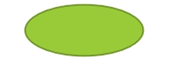
An oval represents a start or end point. The terminator symbol marks the starting or ending point of the system. It usually contains the word “Start” or “End”.
❖ Arrows

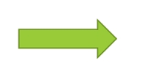
A line is a connector that shows relationships between the representative shapes.
❖ Process
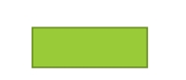
A rectangle represents a process.
❖ Decision
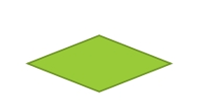
A diamond indicates a decision. It appoints where the outcome of a decision dictates the next step. There can be multiple outcomes, but often there are just two – yes and no or true – false, then branches to different parts of the system flow diagram.

SYSTEM FLOW DIAGRAM
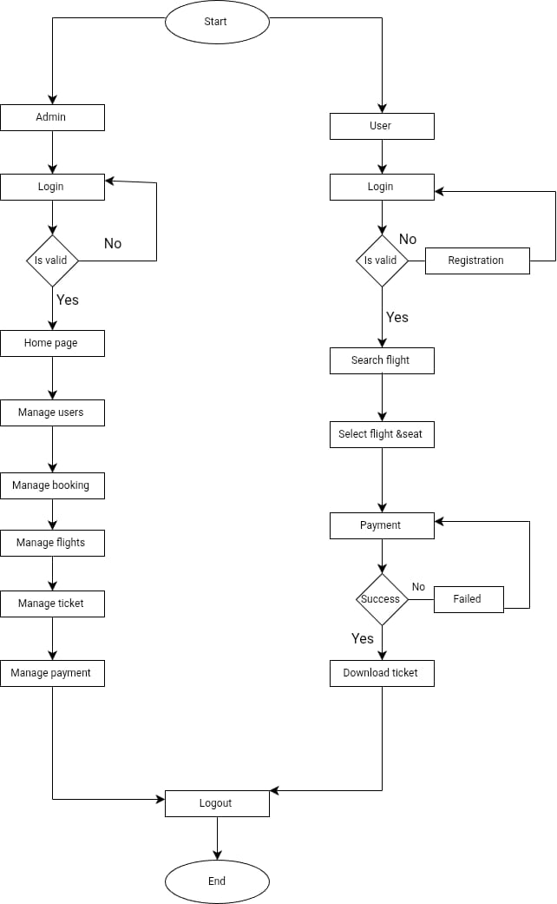

UML(UNIFIED MODELLING LANGUAGE)

• What is UML and it’s use?
Unified Modelling Language (UML) diagrams are graphical representation used for system design to illustrate various aspects of system. The overall goal of UML diagrams is to allow teams to visualize how a project is or will be working. UML can be used to develop diagrams and provide users with ready-to-use expressive modelling examples.
• What is the need of UML Diagrams?
An UML Diagrams are basically used in software engineering and other business processes where modelling is useful. UML becomes essential to communicate with non- programmers’ essential requirements, functionalities, and processes of the system.

Here are some advantages of UML Diagrams:
UML provides a standard language that communicates design information among software developers which saves time and money. Using this language can help developers avoid potential errors in their programs, UML allows developers to reuse code. UML enhances collaboration and provides for a more efficient design process. It also helps identify potential problems early in the design process.

Types of UML Diagram:-

• Use Case Diagram:
An UML use case diagram is the primary form of system/software requirements for a new software program underdeveloped.
• Activity Diagram:
An activity diagram is used by developers to understand the flow of programs on a high level.
• Sequence Diagram:
sequence diagrams is used to document and understand the requirements to establish new systems or learn about existing systems.
• Class Diagram:
Class Diagram is a type of static structure diagram that describes the structure of a system by showing the system's classes, their attributes, operations (or methods), and the relationships among objects.

USE-CASE DIAGRAM
Symbols of use case diagram
❖ Use-Cases

Draw use cases using ovals. Label the ovals with verbs that represent the system’s functions.
❖ Actors

Actors are the users of a system. When one system is the actor of another system label the actor system with te actor stereotype.
❖ System Boundary

Draw the system’s boundaries using a rectangle that contains use cases, place actor outsides the system’s boundaries.

USE-CASE DIAGRAM FOR Admin
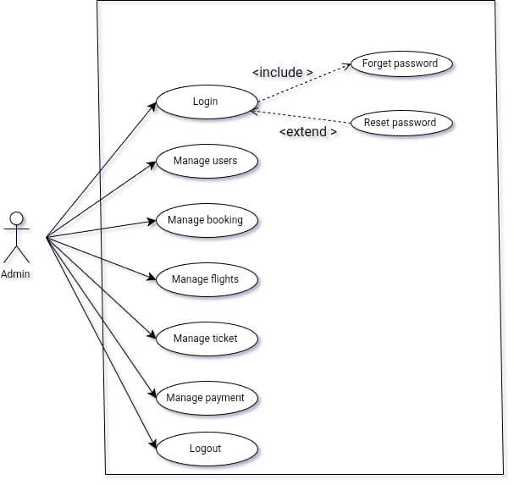

USE-CASE DIAGRAM FOR USER

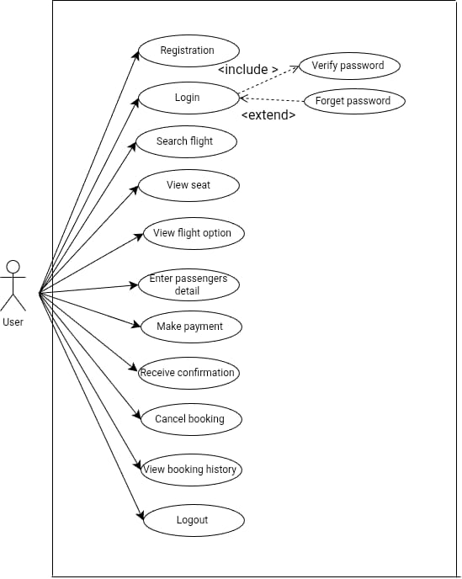

SEQUENCE DIAGRAMS
• What is Sequence Diagram?
Sequence diagram is an interaction diagram which focuses on message interchange between number of timelines. It represents the flow of messages in the system and can also be termed as Event Diagram. It illustrates how the different parts of a system interact with each other to carry out a function, and the order in which the interactions occur when a particular use case is executed.
• Benefits of Sequence Diagram:
Following are some advantages of sequence Diagram:
Sequence Diagram is used for high-level interactions hence helps in understanding developers design and complex system.
It has easy maintenance.
It depicts the message flow between the different objects.
It can easily update as per the new change in the system.

Login

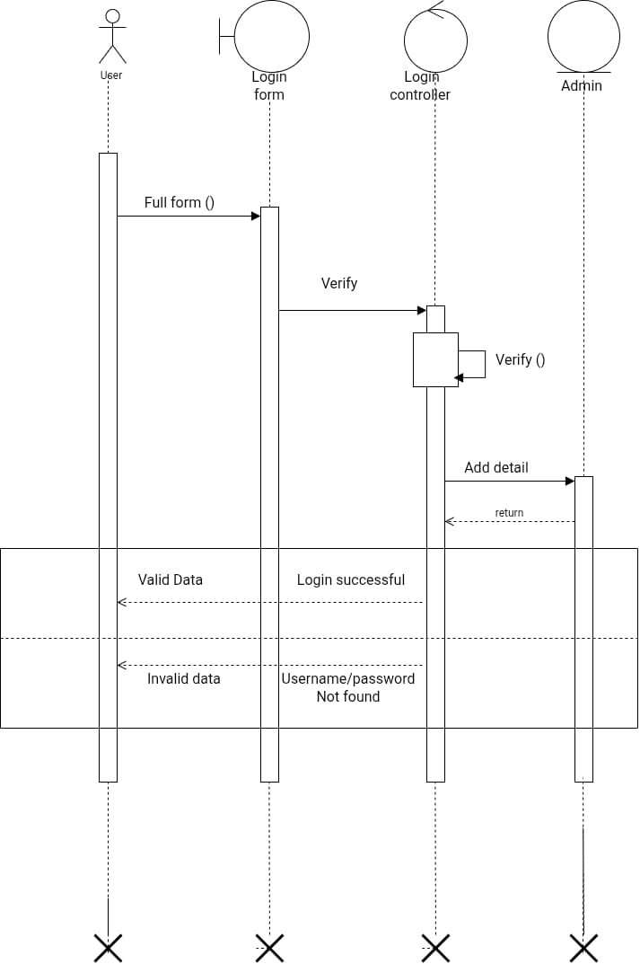
Manage user
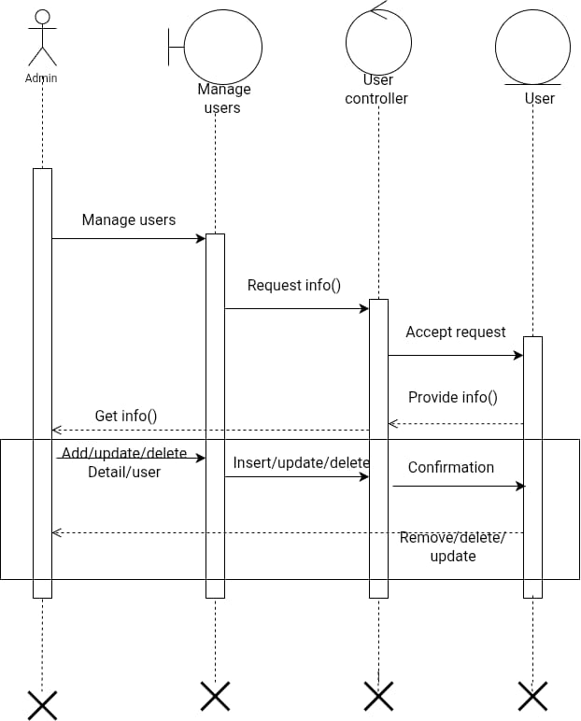

Manage booking
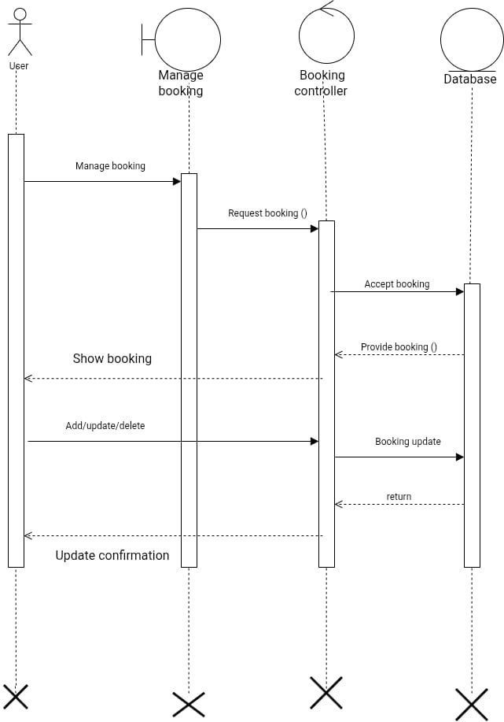

Manage tickets
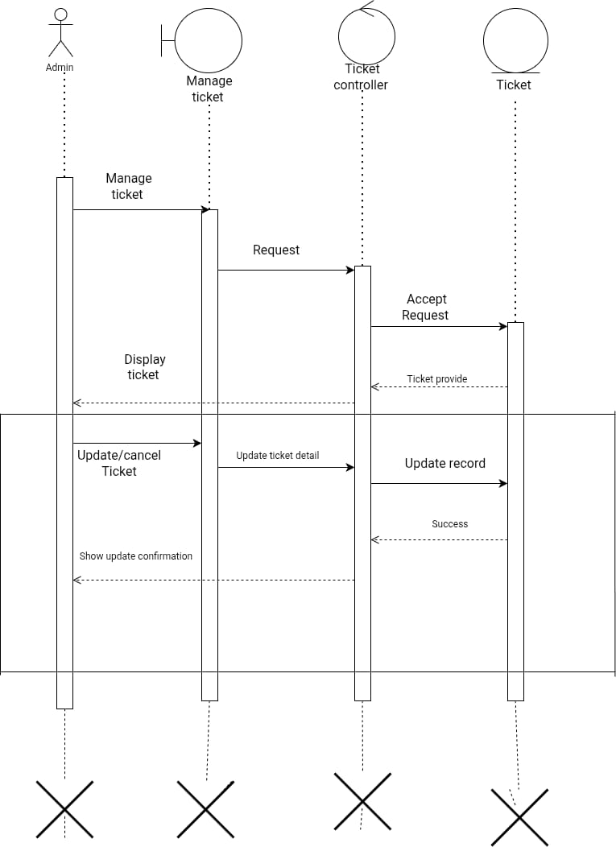

Payment
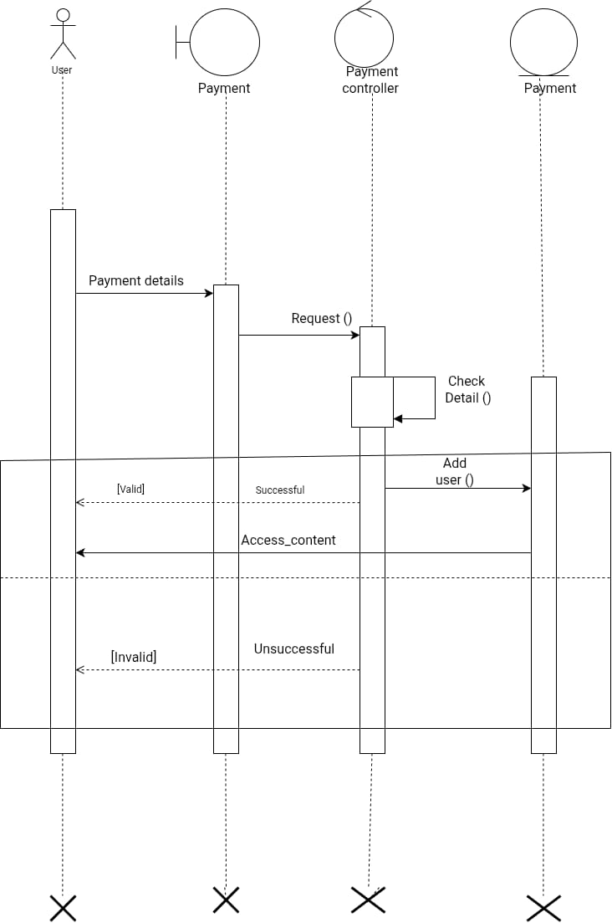

ACTIVITY DIAGRAM
What is Activity Diagram?
Activity Diagram is one of the important diagrams of UML. It represents the flow from one activity to another activity which can be shown as operations of system.
An activity diagram portrays the control flow from a start point to a finish point showing the various decision paths that exist while the activity is being executed.
It represents what activities can be done in parallel and whether there are alternative paths through the workflow.

• Benefits of Activity Diagram:
Shows the progress of workflow amongst the users, and the system. It provides the visual representation of logic of a particular algorithm. It represents the relationship between one activity to another activity. It provides a better understanding of how the system works. We can use Activity diagrams to depict concurrent activities easily.

Symbols of Activity diagram
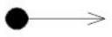
❖ Start / Initial point
Represents the beginning of the process.

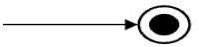
❖End point

Represents the completion of all the flow and end of process.

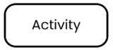
❖ Activity

Indicates the main activity with small description within the shape.

❖ Activity flow

Shows the directional flow of the activity.

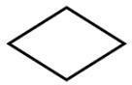
❖ Decision symbol

Represents decision making with one input and multiple output

Activity diagram

Booking
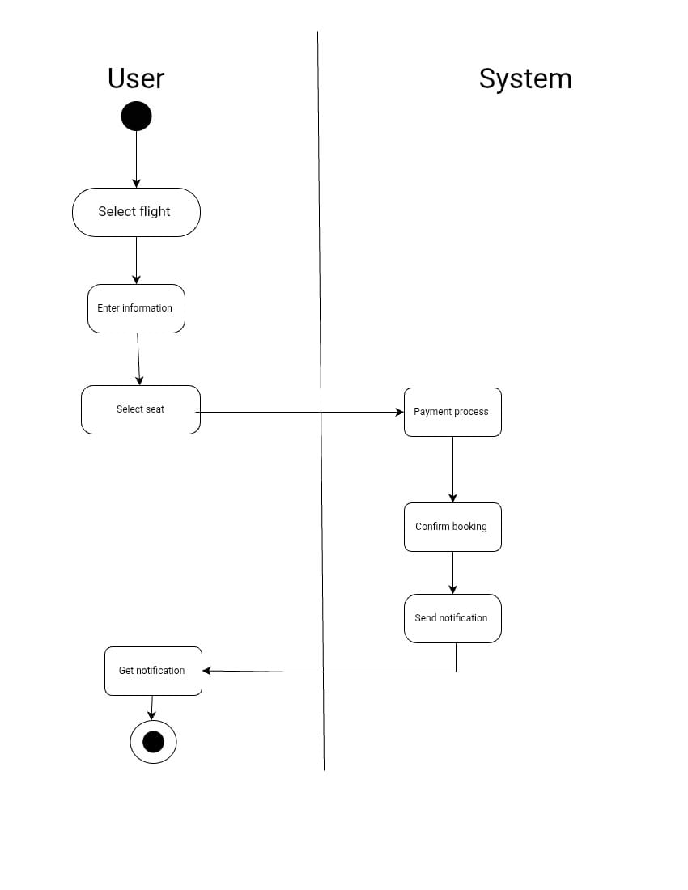

Payment

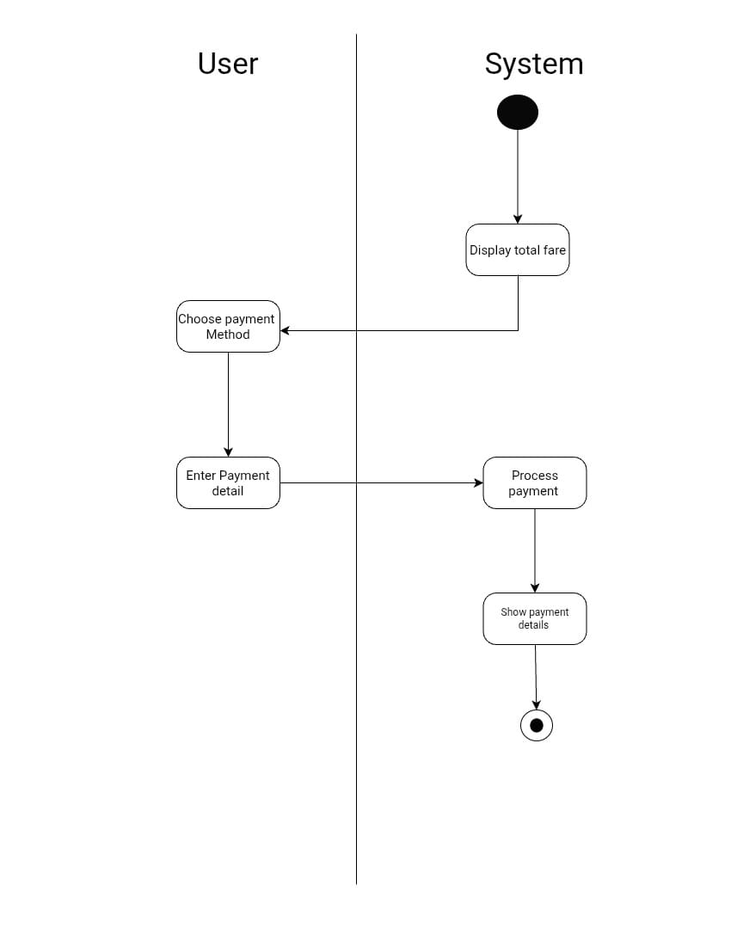

Search flight

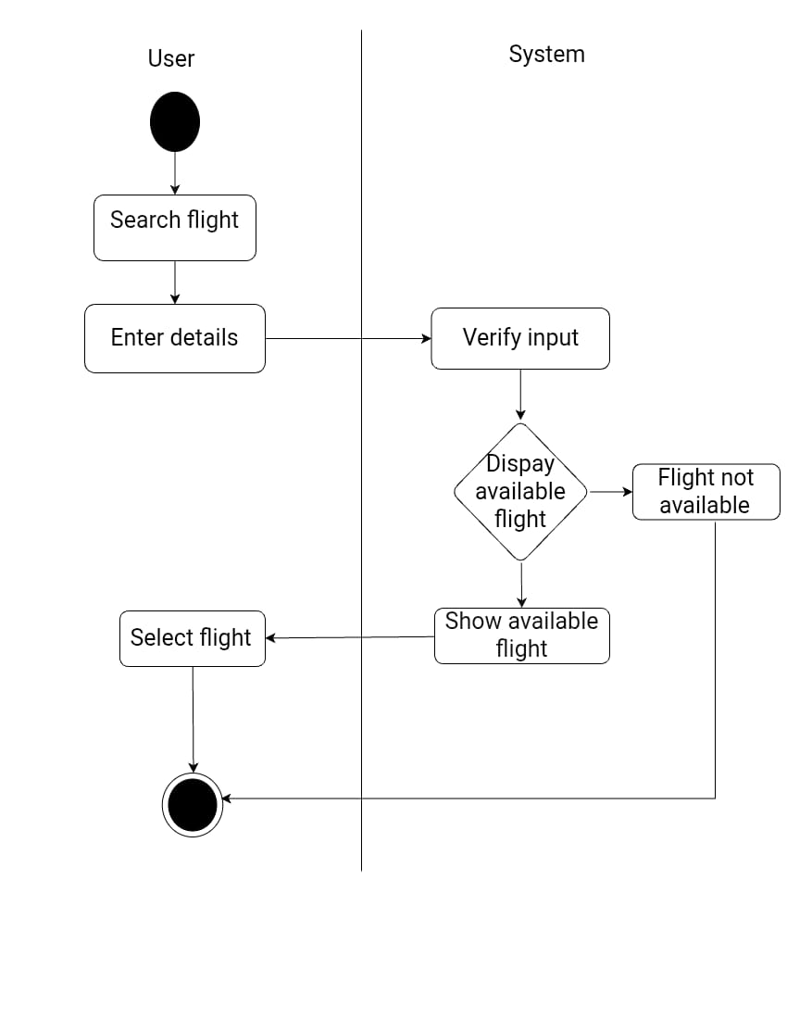

Seat selection
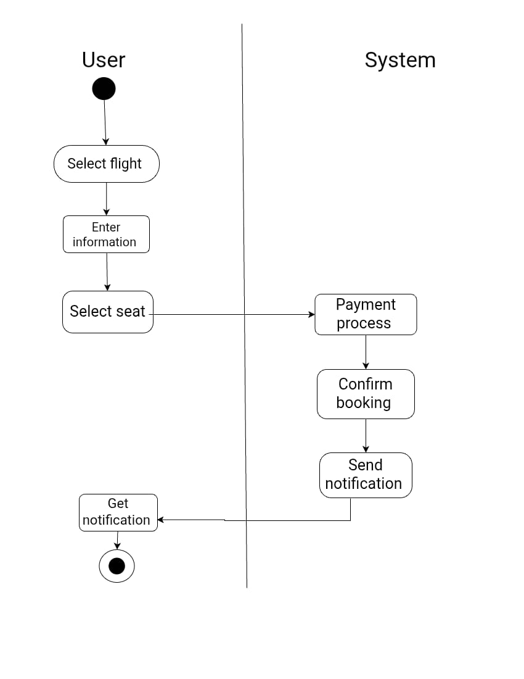

Class Diagram
- Class diagram are one of the most useful types of diagram in UML as they clearly map out the structure of a particular system by modelling its classes, attributes , operations, and relationships between objects.
- Class diagram contain icons representing classes , interfaces and their relationships.
- Since classes are the building block of objects, class diagrams are the building blocks of UML.
- The various components in a class diagram can represent the classes that will be programmed, the main objects,or the iteractions between classes and objects
- The class shape itself consists of a rectangle with three rows. The top row contains the name of the class, the middle row contains the attributes of the class , and the bottom section expresses the methods or operations that the class may use.
- Classes and subclasses are grouped together to show the static relationship between each object.

BASIC COMPONENTS OF CLASS DIAGRAM
- Upper Section
- Middle Section
- Bottom Section

MEMBER ACCESS MODIFIERS
- All classes have different access levels depending on the access modifier(visibility). Here are the access levels with their corresponding symbols:
- Public(+)
- Private(-)
- Protected(#)
- Derived(/)
- Static (underlined)

Class Diagram
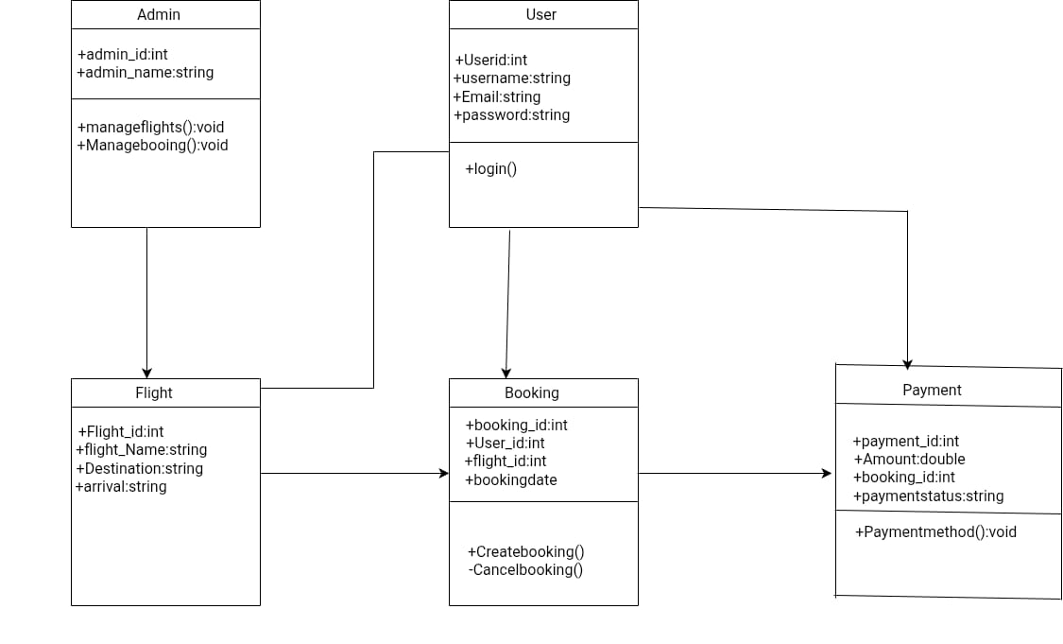

E-R DIAGRAM (ENTITY RELATIONSHIP DIAGRAM)

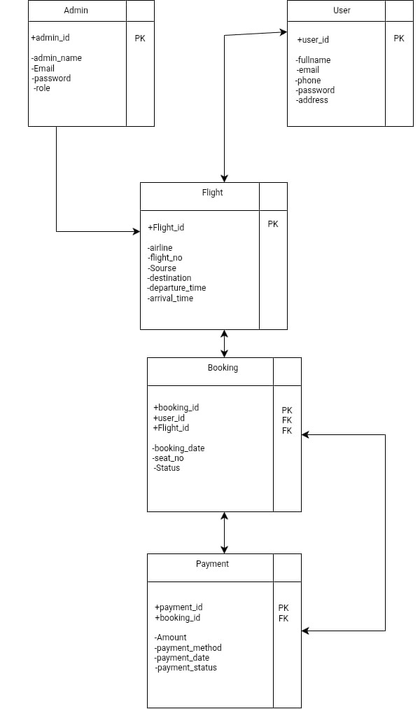

DATA DICTIONARY

1. Admin Table
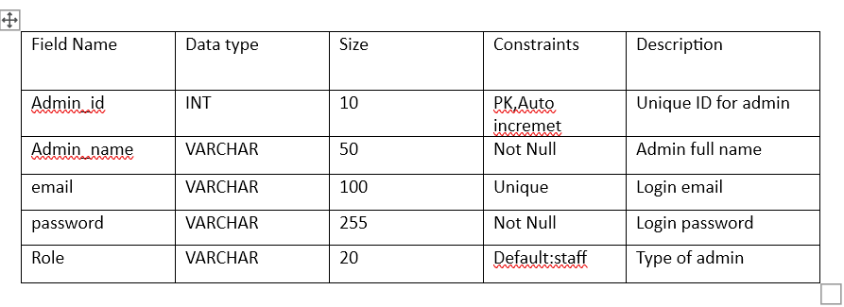

2. flight table

Field Name | Data type | Size | Constraints | Description
Flight_id | INT | 10 | PK,Auto increment | Unique ID of flight
Airline_id | INT | 10 | FK-Airlines | Airlines reference
Flight_number | VARCHAR | 20 | unique | Uniqueflight number
Source | VARCHAR | 50 | Not null | From location
Destination | VARCHAR | 50 | Not null | To location
Departure_detetime | DATETIME | - | Not null | Departure time
Arrival_datetime | DATETIME | - | Not null | Arrival time
Total_seats | INT | 5 | Not null | Total seats
Available_seats | INT | 5 | Not null | Seats available

3. user table

Field name | Data type | Size | Constraints | Description
User_id | INT | 10 | PK,Auto increment | Unique user ID
Full_name | VARCHAR | 100 | Not null | Passenger name
Email | VARCHAR | 100 | Unique | User email
Phone | VARCHAR | 15 | Not null | User phone number
Password | VARCAHR | 255 | Not null | Hashed password
Address | VARCHAR | 255 | Null allowed | User address

4. booking table

Field Name | Data type | Size | Consatraints | Description
Booking_id | INT | 10 | PK, Auto increment | Unique booking ID
User_id | INT | 10 | Fk-user(user_id) | User reference
Flight_id | INT | 10 | FK- flight(flight_id) | Flight reference
Booking_date | DATETIME |  | Not null | Date of booking
Seat_count | INT | 3 | Not null | Number of seats booked
status | VARCHAR | 20 | Defalt:confirmed | Booking status(confirmed/cancelled)

5. payment table

Field Name | Data type | Size | Consatraints | Description
Payment-id | INT | 10 | PK , Auto incremenr | Unique payment ID
Booking_id | INT | 10 | Fk-Booking(booking_id) | Booking reference
Amount | DECIMAL | 10,2 | Not null | Ticket amount
Payment_method | VARCHAR | 50 | Not null | UPI/Card/NetBanking
Payment_date | DATETIME | - | Not null | Date of payment
Payment_status | VARCHAR | 20 | Dafault:Success | Success/Failed/pending

